Line Seguidor

(Line Follower Bot)

***Line Seguidor***

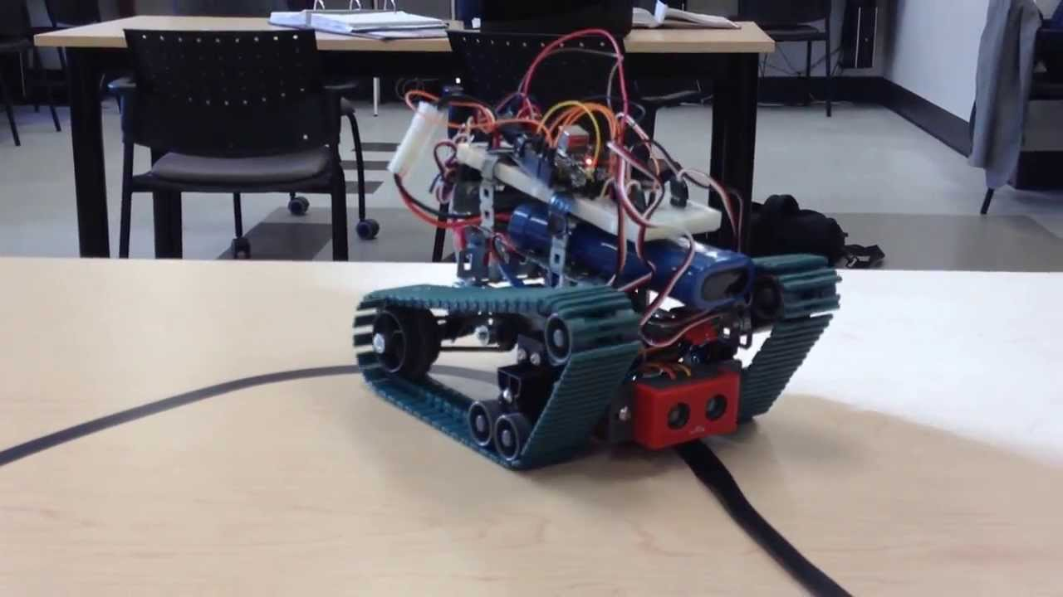

**Contents**

1. Problem Statement

2. Event Rules and Specifications

2.1. Event Structure

2.2. Arena

2.3. Team Size

2.4. Eligibility

2.5. Rules

2.6. Specifications

3. Judging Criterion

4. Resources

5. Contacts

**1. Problem Statement**

The task is to build an autonomous robot that will follow a black line and which can also move if line is broken. It should stop when it come across a black circle.

**2. Event Rules and Specifications**

**2.1. Event Structure**

The robot has to follow a trajectory with curves and right- angled turn. Line would be broken at any point and robot has to cross that and go to other side (in a straight line). The bot should detect the dead end and stop there.

**2.2. Arena**

The below shown arena is tentative one, it can change during the main event.

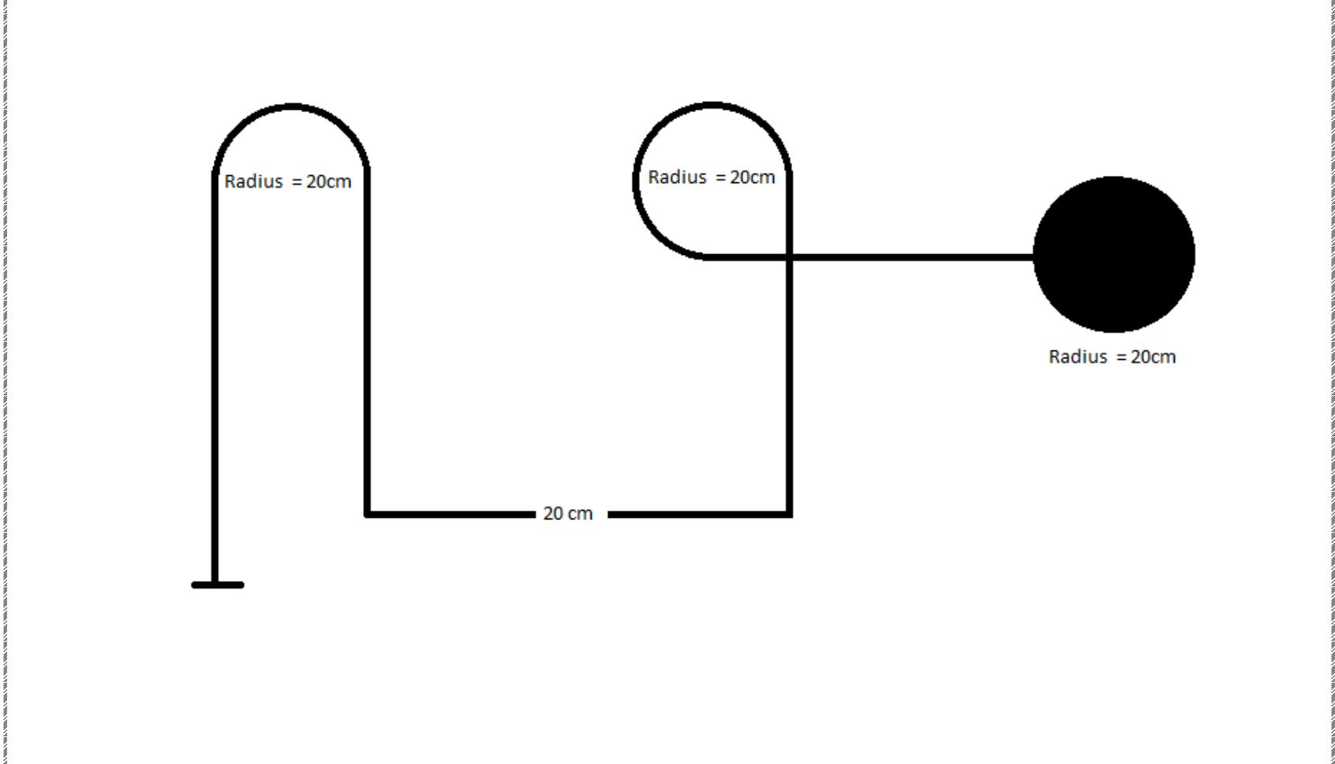

**2.3. Team Size**

• Students from different colleges can form a team. A team may consist of at least 2 members and should not exceed more than 5 members.

• The students must carry valid student ID cards of their college which they will be required to produce at the time of registration.

• Participants shall not be allowed to be a part of more than one team.

**2.4. Eligibility**

Any student from a recognized institute/college can participate in this event.

**2.5. Rules**

• There are maximum 2 tries+1 trial that will be given to each team and total time should not exceed 15 minutes.

• No readymade components should be employed in making the robot. (Except-microcontrollers)

• If any team is found harming the arena, the team will be disqualified on the spot.

• In case of wireless robot, it should contain its own power supply.

• Ignus team will not be responsible for any damage done to the robot in the arena.

• In case of any discrepancies, the decision of the event coordinators will be final.

**2.6. Specifications**

• The width of the black line will be 3cm.

• Dimensions of the Robot should be less than 20cm*20cm*15cm (lxbxh).

• The participants have to ensure that room lighting, photography does not affect the functioning of the sensors.

• The machine can use only onboard electric power supply.

• Maximum voltage in the circuit should not exceed 12V at any time.

**3. Judging Criterion**

**All decisions taken by the organizing team will be deemed as final, and no more changes will be encouraged, thus holding the full authority to change any of the above rules as per circumstances.**

**4. Resources**

[https://www.youtube.com/watch?v=JDxIorDI1V](https://www.youtube.com/watch?v=JDxIorDI1VQ)Q

[http://playwithrobots.com/make-it-form-scratch/simple-line-follower-robo](http://playwithrobots.com/make-it-form-scratch/simple-line-follower-robot)t

[https://www.sparkfun.com/tutorials/5](https://www.sparkfun.com/tutorials/57)7

**5. Contacts**

**Divyansh Aggarwal**

**7222807790**

**aggarwal.1@iitj.ac.in**